Hack The Box Academy

INTERNET SECURITY

Sit amet, consec tetuer

adipiscing elit, sed diam nonummy nibh euismod tincidunt ut laoreet dolore magna aliquam.

NETWORK PROTECTION

Ut wisi enim ad minim veniam, quis nostrud exerci tation

ullamcorper.Et iusto odio

dignissim qui blandit

praeseptatum zzril delenit

augue duis dolore te feugait

nulla adipiscing elit, sed diam nonummy nibh.

PERSONAL FIREWALLS

Tincidunt ut laoreet dolore magna aliquam erat volut pat. Ut wisi enim ad minim veniam, quis exerci tation ullamcorper cipit lobortis nisl ut aliquip ex.

Information Technology Solutions

INFO

SSH & username & password already given.

5 Flags to find

Searched for the flags to know where there are located.

For flag2 an other user is needed

Information Technology Solutions



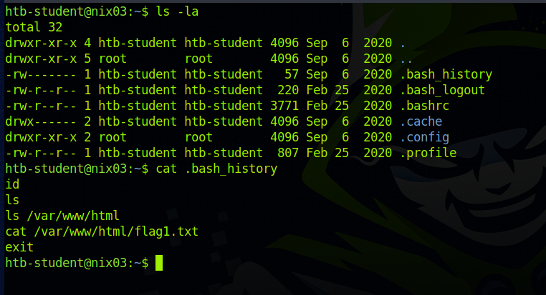

Flags are all called the same, flag1.txt, flag2.txt, and so on.



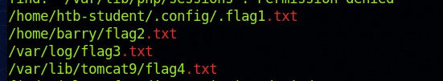



Linux Privilege Escalation (Tier II) Assessment

Flag 2

Info

For Flag 2 we need at least read access.

.bash_history

Htb-student has read access to barry’s .bash_history which contains useful information

Information Technology Solutions

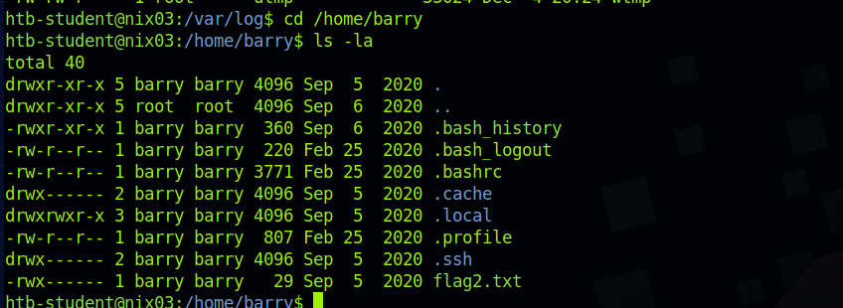

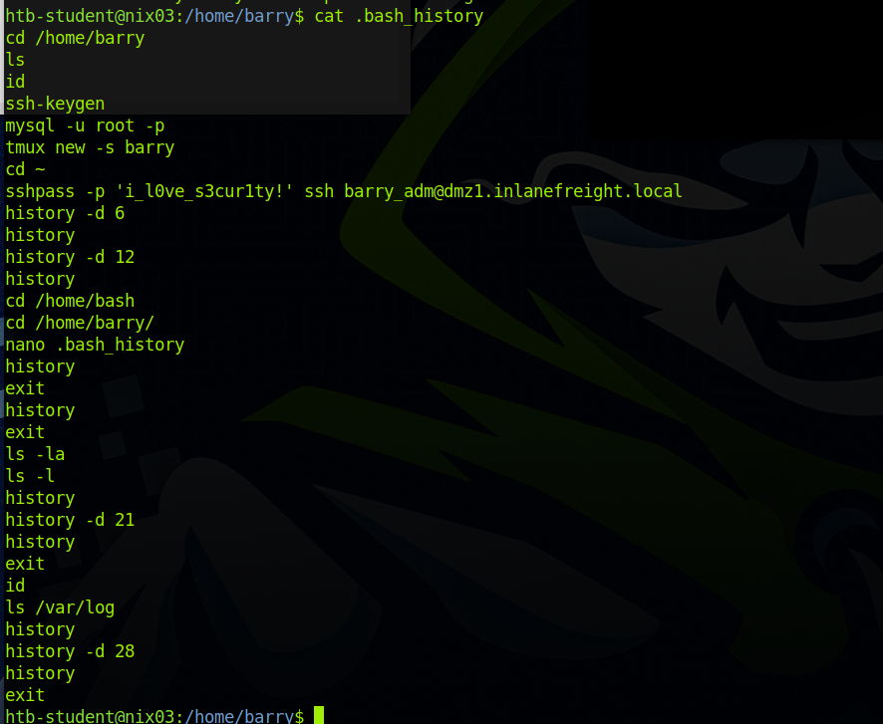

Info

Logging into barry’s account we can look into the Flag 2

Flag 2

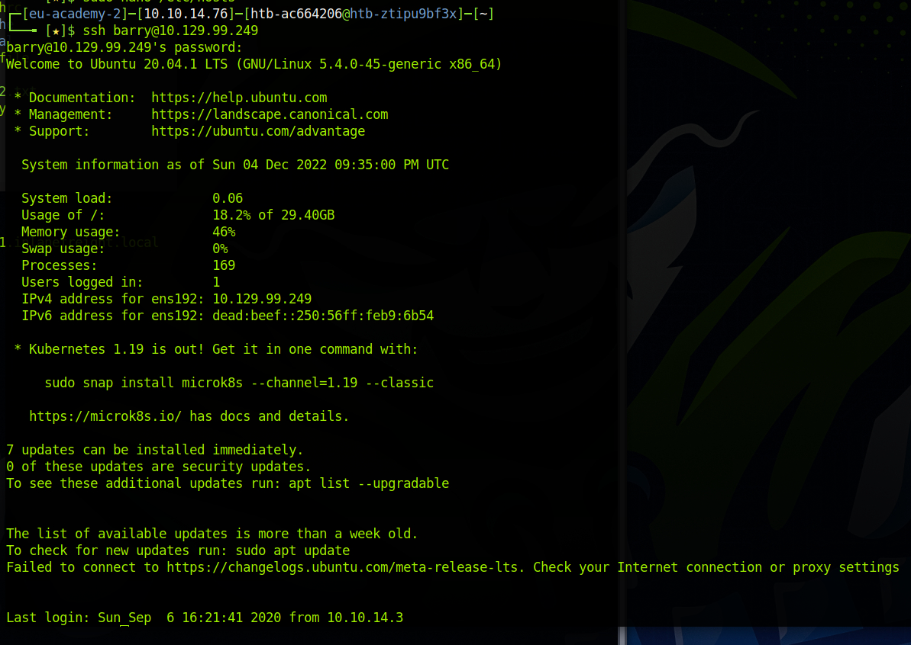

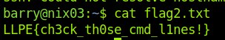

Info

Flag 3 for free

Flag 3



Info

For flag4 the tomcat user is needed.

Which could lead to a tomcat server.

Inside the logs there are hints for a directory and webserver

Flag 4

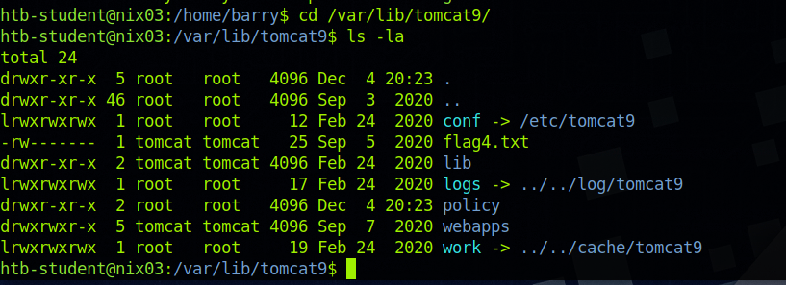

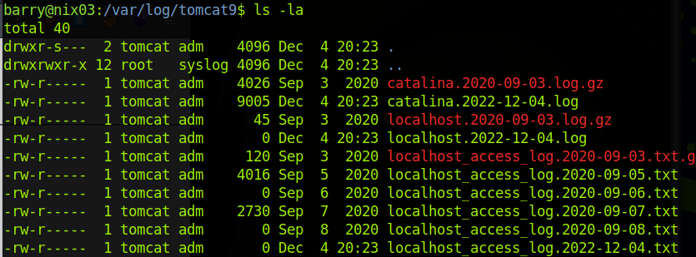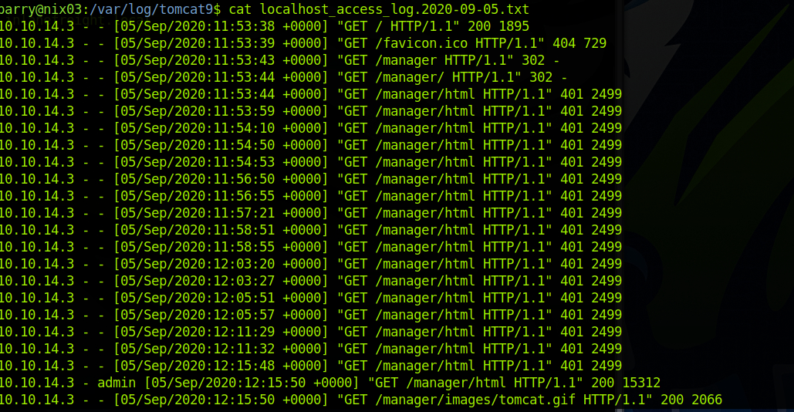

Info

(Without nmap)

We can see some Ports used.

Port 8080 is the tomcat webserver.

There is a .bak file which can be accesed.

Flag 4

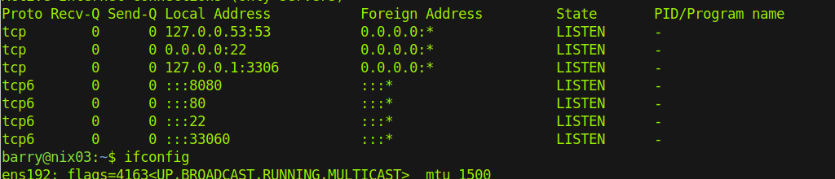

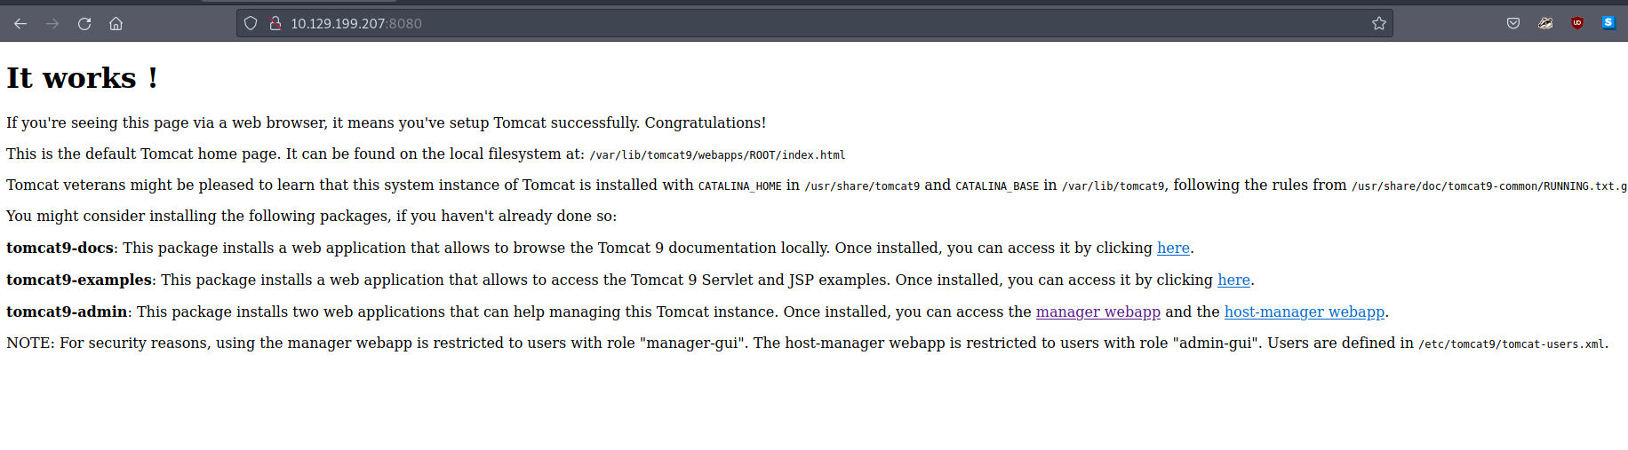

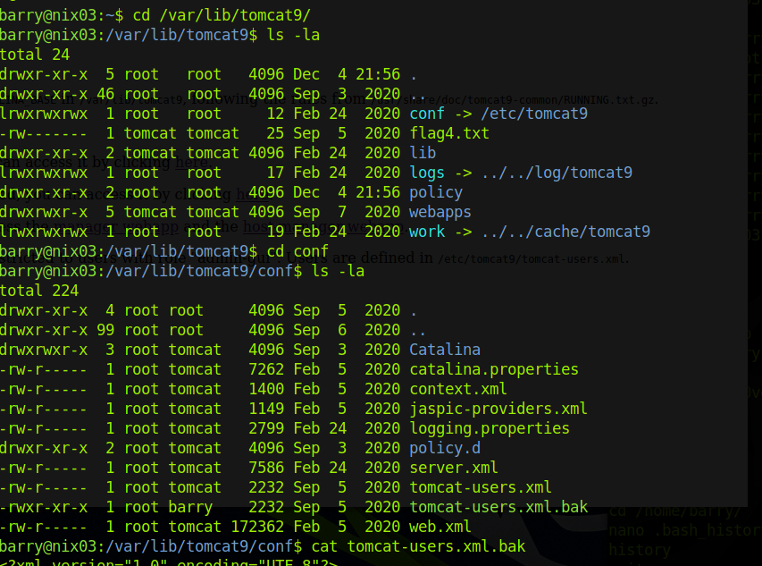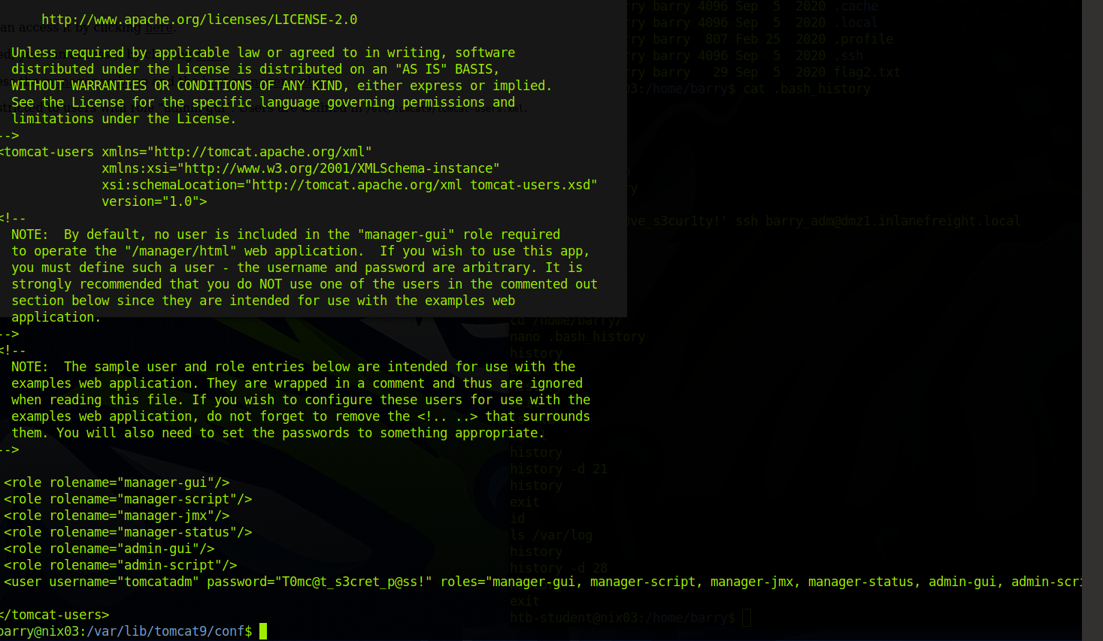

Flag 4

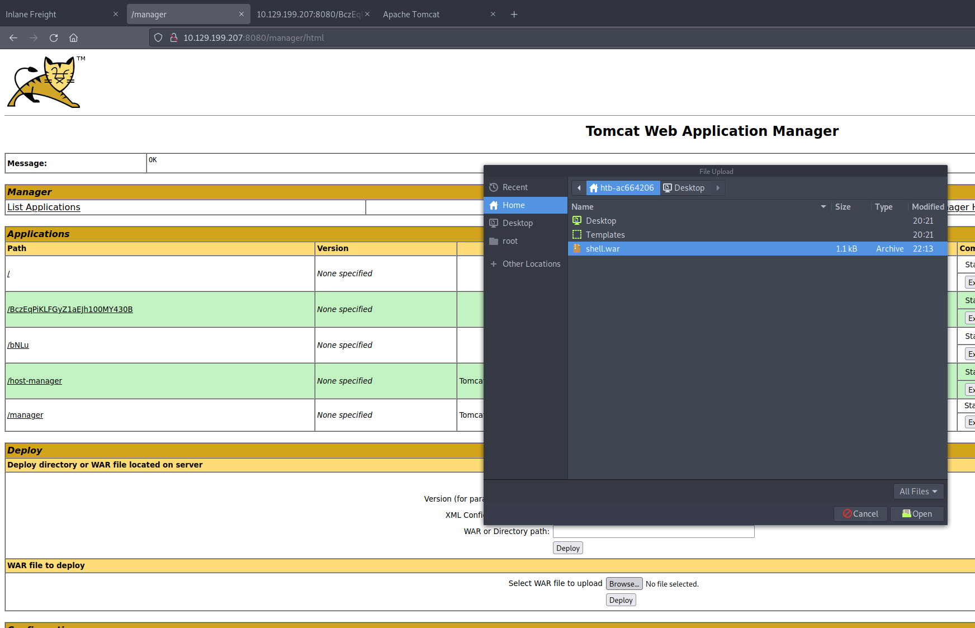

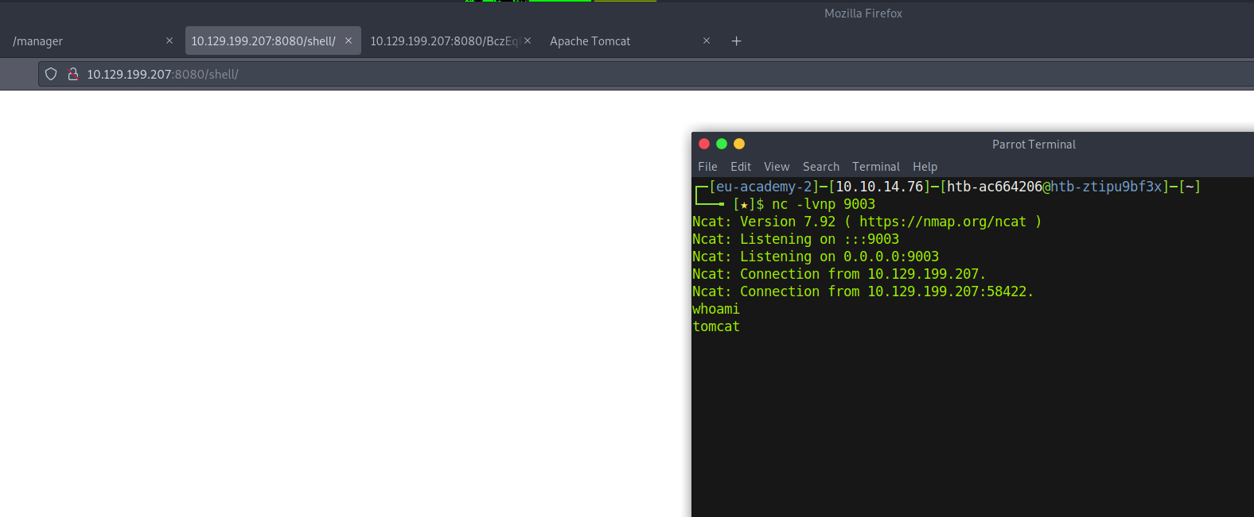

Info

Uploading the generated .war file to the webserver

Using nc and visting the malicious site returns a shell with the tomcat user

Flag 4

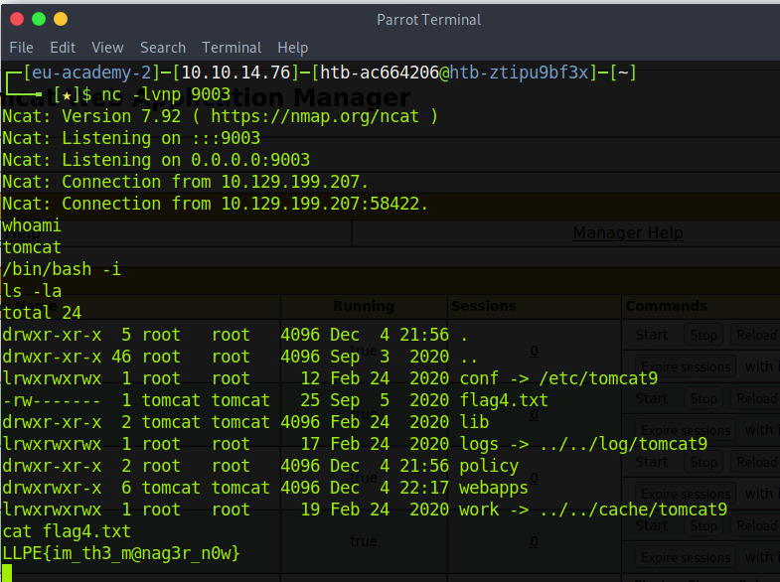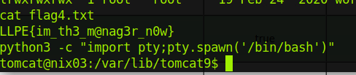

Info

Flag 4 !

Flag 5

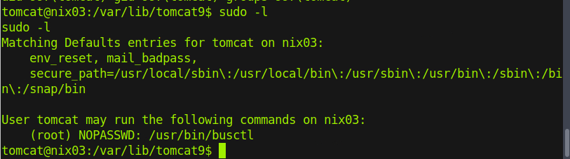

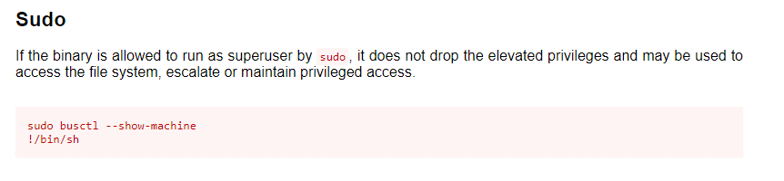

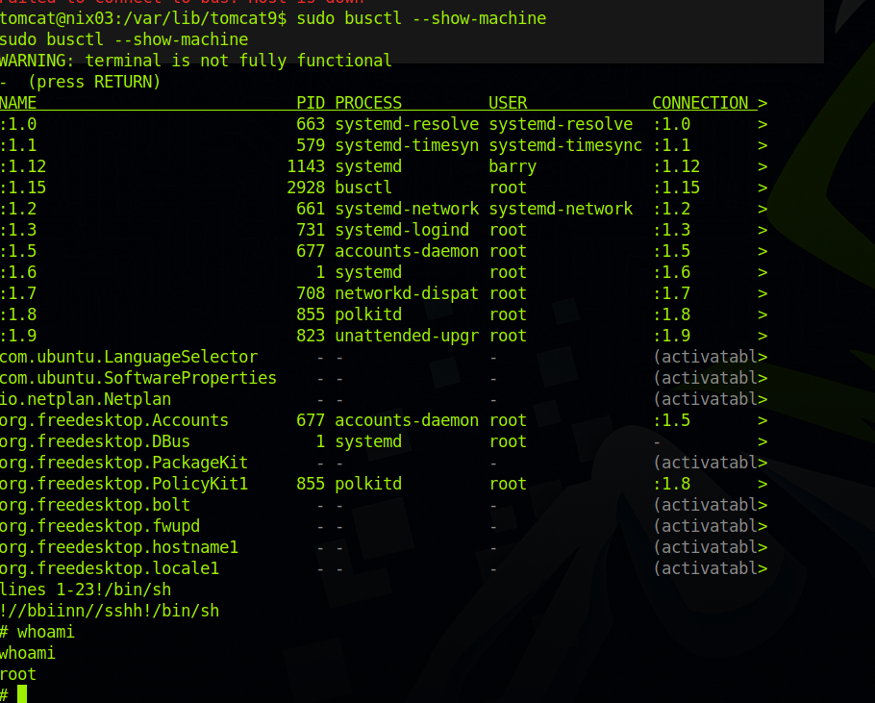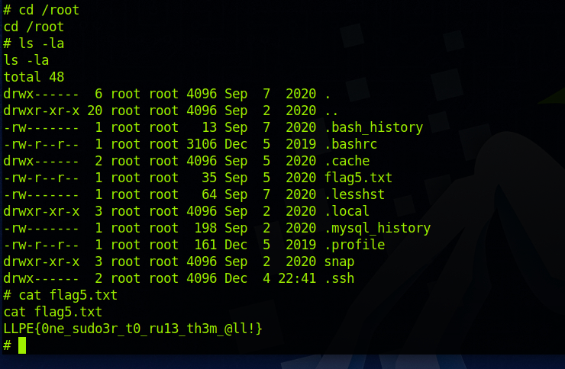

Info

The tomcat user can run a command as root

Searching for busctl on how to escalate privilege gives us:

https://gtfobins.github.io/gtfobins/busctl/

Flag 5







Flag 5



